Asimov’s Chronology of the World: …From the Big Bang to Modern Times, Harper Collins 1991 First Edition, First Print full number line. As new unclipped dust jacket price $35.00. As new, never read, hardcover with all 674 pages of text unmarked in any way. In this amazingly comprehensive work, Isaac Asimov tells the story of life on our planet from the Big bang to the end of World War II. ISBN 0062700367
ID 000104 Price $50
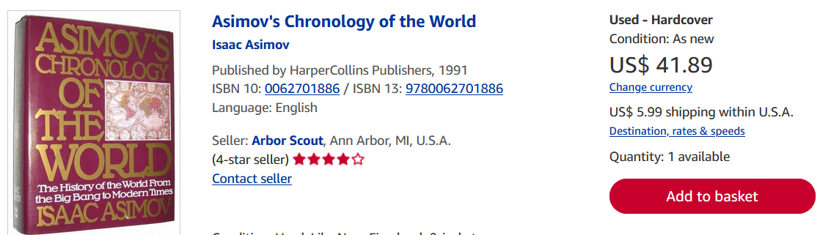

BookFinder 167 copies

